1920 Replicas – 1000 Partitions- 100 Topic

3 Producer 2 Consumer (Double Rebalancing)

Load Test Duration – 00.49-01.28 (Rebalance Triggered at 01.22)

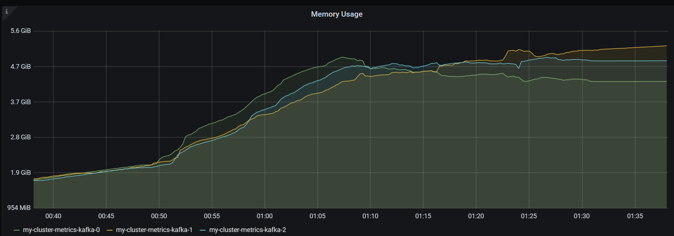

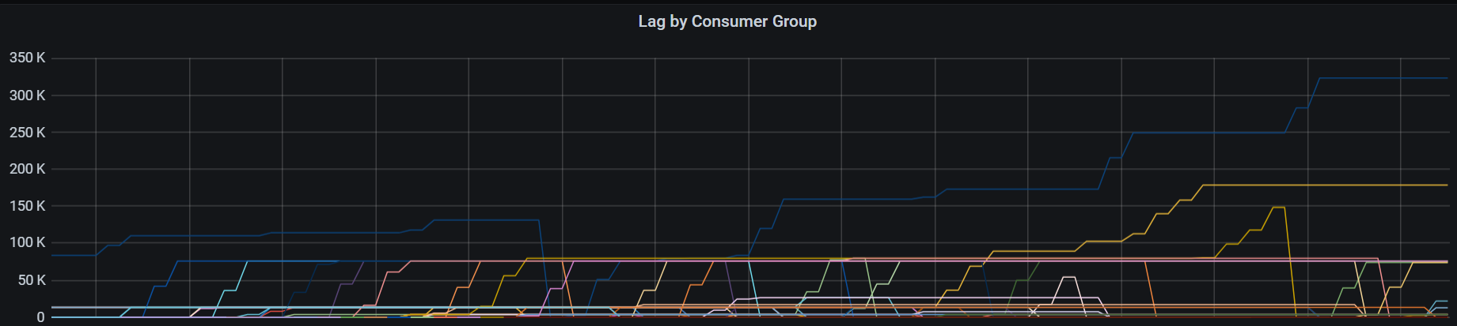

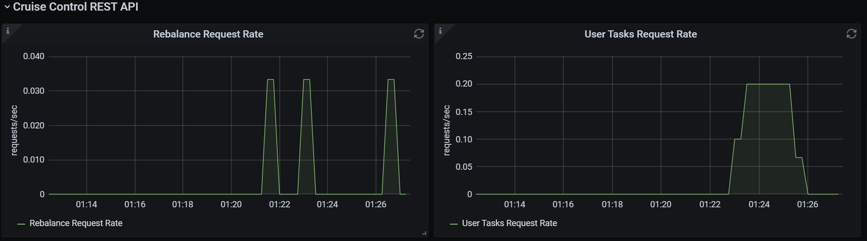

Consumer Msg Lag

70.7

75